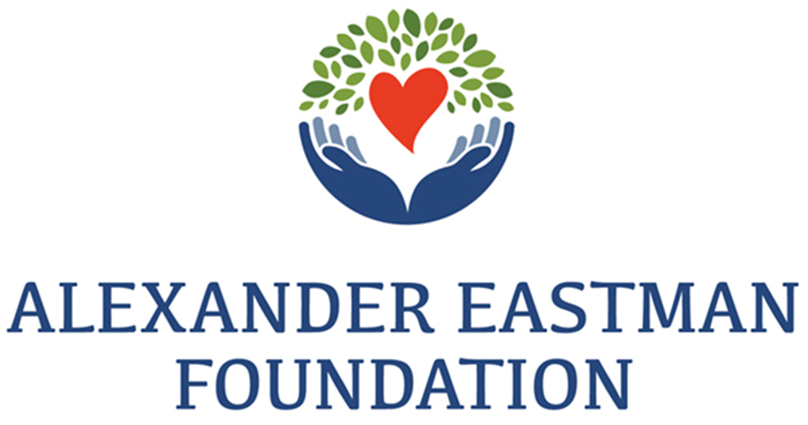
aefnh.org
Promoting Health and Well-Being for Residents of the Greater Derry, NH Area Since 1930

Strategic plan 2023 - 2026
leveraging knowledge and resources

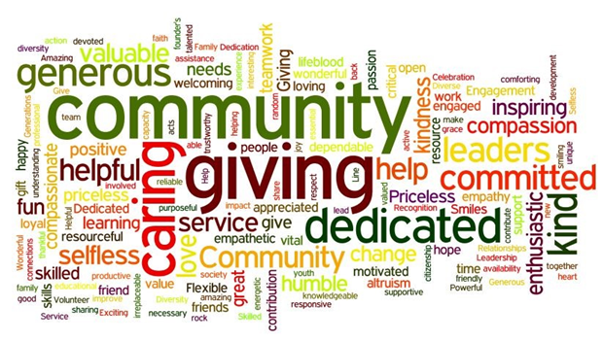

Executive Summary
Over the past few years, the nonprofit sector, our community, state, nation, and the world have faced unprecedented health and wellness challenges. Through it all, nonprofits have demonstrated remarkable resilience. However, the isolation the pandemic brought about intensified the insular management of many of our community nonprofits. As we recover, we must implement new ways to deliver services, of connecting, of work, and of looking forward.
The Alexander Eastman Foundation must be nimble, raise our voice, and leverage funding and resources to respond to the needs of our nonprofit community. To do this, the Foundation must commit to strengthening and investing in the external and internal capacity of the Foundation.
This Strategic Plan 2023-2026 reflects the Foundation’s evolution. We are stretching to use our knowledge and resources in new places and in new ways on behalf of all of our nonprofit partners.
Mission Statement
The Alexander Eastman Foundation strengthens and gives voice to the Greater Derry Community’s Health and Wellness through leadership, collaboration, and funding opportunities.

Vision Statement
All individuals, and families, thrive because our community is home to vibrant, impactful nonprofits.

Values
WE BELIEVE in the power of nonprofits to create positive, lasting change.
WE EMBRACE diversity, equity, and inclusion.
WE ARE COMMITTED to excellence and continual learning.
WE CHALLENGE ourselves to be forward thinking, resourceful, and bold.
WE BELIEVE in the power of community.

Our Future
1 - Be a bold champion and advocate for the community.
2 - Support the nonprofit community in a continually changing landscape.
3 – Strengthen the Foundation’s Capacity
4 - Advance Diversity, Equity, and Inclusion.
Be a Bold Champion and Advocate for the Community.

Convene and inspire community stakeholders.
- Evolve, grow, and diversify the Foundation’s policies and community leadership.
- Further engage our community base through thoughtful awareness of the Foundation’s advocacy activities, and initiatives.
- Enhance engagement through leadership and partnerships.
- Leverage the collective influence of nonprofit and community service organizations.
Advance priorities of the sector with policy makers and funders
- Identify opportunities and proactively engage to advance solutions that support community health and wellness.
- Establish and nurture relationships with policy makers, funders, and key influencers.
- Advocate for streamlined grant processes, and flexible resources.
Raise the profile of the Foundation and its vital effect on the Greater Derry Community.
- Leverage social and local media to increase the impact of the Foundation.
- Increase understanding of the unique circumstances of nonprofits.
- Ensure the Foundation has a leadership seat at decision making tables in our community.

Support the Nonprofit Community in a Continually Changing Landscape.

Support local nonprofits and community service organizations manage their operational functions.
- Create and support a cooperative “back office” shared services for community organizations.
  - Office Administration
  - Finance / CFO / Audit
  - Human Resources
  - Purchasing
  - Grant Writing
  - Fund(s) Management
  - Other areas as needed.
- Advocate for our local community organizations by identifying resources and engagement opportunities.
- Assist in building the awareness of community residents of the need for volunteering, and financial commitment. “It takes a Village.”
Develop and Support the operation of a community center.
Strengthen the Foundation’s Capacity

Strengthen and invest in the internal capacity of the Foundation.
- Ensure that the Foundation has the staffing, financial, and technical resources to respond to the growing health and wellness needs of the community.
- Leverage technology to expand our reach throughout the community.
- Invest in the continuing professional development and care of the Foundation’s staff, and board.
- Commit to reinvesting in the Foundation, so that the Foundation can better serve the community for the next century of service.
Develop new revenue sources and funding.
- Develop the AEF Community Legacy Fund.
- Implement online donation portals and QR code.
- Actively seek available grant funding for the Foundation.
- Offer management services to local charities.
- Seeking new opportunities.

Advance Diversity, Equity, and Inclusion.

Demonstrate the Foundation’s commitment to DEI principles.
- Continually access the Foundation’s own actions and accountability, in accordance with our Diversity and Inclusion Statement.
- Impower a DEI sub-committee to provide ongoing guidance and support for Foundation’s community commitment.
- Help our community partners understand the importance of DEI.
- Incorporate the Foundation’s DEI statement and commitment on the AEF website.

“Never doubt that a small group of thoughtful, committed, citizens can change the world. Indeed, it is the only thing that ever has.”
- Margaret Mead

Analysis of the Current State of the Foundation

The Alexander Eastman Foundation is a charitable nonprofit organization founded in 1930 as the Alexander Eastman Hospital Corporation (AEHC) which opened the first hospital in the area in 1934 in East Derry. In 1964 a new hospital was built on Birch St in Derry; this was operated until 1983 when the hospital was sold to the Hospital Corporation of America. With the proceeds of the sale the AEHC became the Alexander Eastman Foundation (AEF).
The Foundation’s mission is to promote Health and Wellness programs, community education, and initiatives. The Foundation supports other community nonprofits and initiatives in the AEF’s service area of Windham, Londonderry, Derry, Chester, Sandown, and Hampstead, with annual grants. The Foundation has invested in excess of ten million dollars into the Greater Derry area over the past forty years, with $4.6M donated since 2015.
AEF founded, developed, and has funded two nonprofit community service organizations which are now both separate entities from the Foundation.
The Greater Derry Community Health Services (CHS) is a program funded through grants, community service contacts with the towns of Derry, Londonderry, and Chester, and donations that works to meet the health access needs of vulnerable residents for over twenty years. AEF has provided over $1.5M in funding to CHS since 2015.
In 1992, the Foundation convened a workgroup of dentists, school nurses and principals to develop a school-based dental program. The resulting program operated from 1993 -2006 as the Alexander Eastman Foundation School Dental Program with Alexander Eastman Foundation funds that were administered by the Londonderry School District. When the non-profit Greater Derry Oral Health Collaborative Corp was formed in 2006, services and funding remained the same under the trade name Children’s Dental Network. AEF remains a major funder for this program, 2015-22 $825k.
Other organizations which the Foundation has funded from inception or every year since 2015 include Community Care Givers $230k, the Upper Room $414k, Planned Parenthood of Northern New England $$225k, Rockingham Meals on Wheels $232k, Sonshine Soup Kitchen (exception 2022) $90k, Isaiah58 $127k, and the NH Food Bank (exception 2022) $175k.
Over the past two years the Foundation has re-engineered its internal management and worked to re-focus on how it can best support the needs of the community it serves. While providing monetary grants to various organizations is critical to our mission, other means of support have been reviewed.
Areas most frequently identified by area nonprofits is the need for communication, shared strategies, and vision between local organizations. Communications between organizations operating in silos which had become increasingly insular during the pandemic has created many duplicated services and a complicated maze for those seeking services to navigate.

As the Foundation is a large funder for many of these organizations, it has the unique ability to act as a community facilitator and help develop avenues of communication and mutual support, while assisting each to grow and thrive.
Additionally, the Foundation is supporting efforts to develop a Multi-Generational Center which will service the greater Derry community and is exploring ways to help support the “back office” functions of smaller service organizations and nonprofits in our area in a cooperative function.
Top 3 challenges the Alexander Eastman Foundation faces:
- Recruitment of volunteer members to serve on our Board of Trustees from all six of the communities in our catchment area. (Derry, Windham, Londonderry, Chester, Sandown, and Hampstead)
- Developing and maintaining community awareness of the Foundation in all of our communities.
- The need for community health and wellness programs is increasing annually yet our endowment has not been built on for many years. In order that we can fund more programs we must seek new sources of funding, which importantly, must not compete for the same sources our grantees receive their funding from.

Top 3 assets or characteristics that help make AEF a successful nonprofit:
- “What Can We Do To Help?” The Foundation has been referred to as a Community Diamond, for almost one hundred years AEF has worked quietly to support and develop services which provide for those in need in our community.
- The Foundation makes every attempt to seek and support new community projects and initiatives related to health and wellness efforts in our community, while maintaining its support for established programs.
- Starting with the nine million dollars the Foundation received from the sale of the hospital in 1983, over ten million has been reinvested in the community. Despite current market conditions, we maintain approximately ten million in our funds. The management of the Foundation’s funds and trusts has been done by a money management firm that specializes in nonprofits and is overseen by a dedicated Board.

A grant award is an investment in positive change. It is a tool the Foundation can use for having an impact on issues it cares about.

